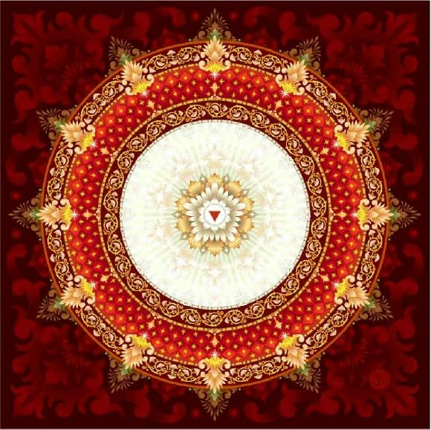
Sarita Elizabeth Cox, ND, LAc
www.drsaritaelizabeth.com
817 21st Avenue, Tuscaloosa, AL 35401
1715 23rd Avenue, Meridian, MS 39301
appts@drsaritaelizabeth.com 205.310.7197

Homeopathy–Nature Cure-Lifestyle/Diet Consultation-Chinese Medicine-Corporate Wellness

Event:

Date:

Time:

Organization:

Event Sponsors:

Topic:

Other speakers/Other speakers fees:

Number of Attendees:

Lunch provided to attendees by:

Capacity to facilitate on site registration for Dr Cox’s upcoming events

Capacity to sell health and wellness products relevant to talk

Please let us know in 100 words or less why Dr Cox would be an asset at your event.

